ABSOLUTE PUBLIC AUCTION
Located at 5230 Willowdale Road Urbana, Ohio 43078
Directions: From Terre Haute go east ½ mile on Storms Creek Road then turn South on Willowdale Road ¼ mile to auction. Approx 3 miles Northwest of Tremont City.
SATURDAY OCTOBER 13TH 10:00 A.M.
Real estate selling at 1:00 PM. Situated on 1.29 acre lot. Consisting of 4 bedroom ranch home, large kitchen with w/ built in appliances, 3 full baths, large living room open to kitchen, large family room, central vac system, 2,320 sq ft of living area. detached 28 x 40 garage w/ room for 4 cars and 12 x 28 carport. Real estate taxes are $1,157.85 per half, | 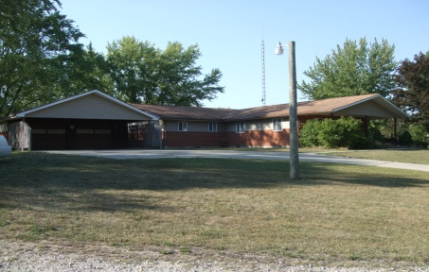
and will be prorated to day of closing. selling absolute to the highest bidder with no reserve. Terms: $10,000. down at auction balance in full at closing within 30 days. Possession given at closing. Selling in its present AS-IS condition. Any inspections, need to be completed prior to auction. Selling with no contingencies. Don’t miss out on this property. You will find this home in move in condition and a great location. OPEN HOUSE: Sunday Sept 9th and Sept 23rd 1-2pm.or by appointment. Call 937-606-0588 auctioneer/realtor Phil Thompson with Ohio Real Estate Auctions LLC. Barry Baker - Broker Starting at 10:00 A.M. Antiques & Collectibles: large early ash 2 pc cupboard; decorated oak 2 door ice box; oak secretary; 1 pc pine wardrobe; Seller’s kitchen cabinet; 5 leg oak table; 2 oak wash stands; cherry drop leaf table; child’s oak rocker; oak desk w/ turned legs; 2 oak stands; oak dresser; 3 oak T back chairs; 2 painted plank bottom chairs; ice cream parlor chair; hall tree; chrome dinette table and 6 chairs; 8 day Seth Thomas wall clock; Oak kitchen clock; New Haven clock; United electric horse clock; possibly Roseville umbrella holder; Roseville 4” vase; McCoy Bananas cookie jar; 2 oil bracket lamps; Bavaria chocolate set; several pcs. of opalescent hobnail including cake stand; blue cruet; other glassware; 3 decorated match safes; 3 canning crocks; decorated milk can; milk stool; old books; Household Goods: Grandmother’s clock in walnut case; Kenmore textured door refrigerator; Maytag W& D set in almond; 2 upright freezers; small chest freezer; 3 cushion recliner couch; 2 love seat rocking sofas; (2) 3 cushion couches, 2 cushion couch & chair; 4 cushion couch; 4 end tables; pine desk; cedar chest; beds and dressers and chest of drawers; 2 book cases; table and floor lamps; touch lamps; 2 porch gliders; yard wind mill; Filter Queen sweeper; From the garage: portable air compressor; Sears Wet & Dry shop vac; Century 100 AMP battery charger; Echo chain saw; Homelite YardVark; 3 gas weed trimmers; alum. ext ladder; several step ladders; wheel barrow; lots of good hand tools and garden hand tools ; electrical tools; some air tools and air impact sockets; tool boxes; lg bolt cutter; sm. floor jack; bottle jack; ext. cords; Terms on personal property: cash or check w/ proper ID only. Also MC, Visa, & Discover accepted w/ 4% clerking charge. Auctioneer’s note: Many items too numerous to list. Go to auctionzip.com for photos, Auctioneer ID # 5640
GBKB ENTERPISES

Food by
“The Farmer’s Daughter”

