BARLOW AUCTION
Saturday, August 2, 2014, 10:30 A.M.
6867 Lakeland Ct., West Chester, OH

REAL ESTATE – HOUSEHOLD – ANTIQUES
CLUB CAR GOLF CART – TROY BILT SNOW THROWER

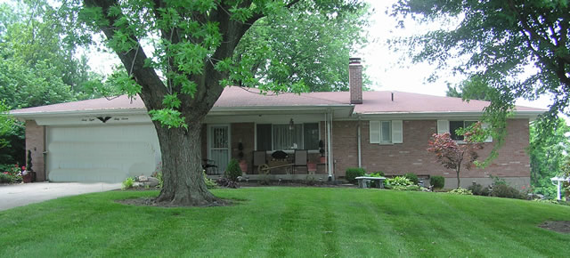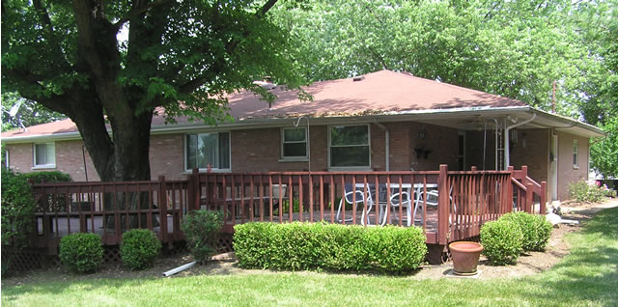
Front View of Home Rear View of Home

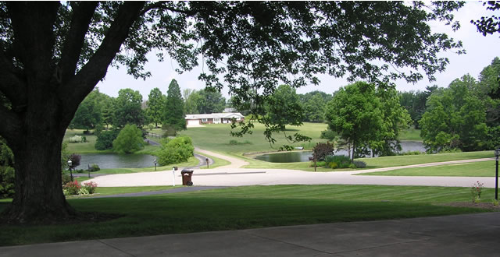
Fantastic View from Front Porch

REAL ESATE (Sells at 12 Noon) – Outstanding Location, One-Owner from new.
3-bedroom quality built brick ranch on cul-de-sac with fantastic view of 2 beautiful lakes down hill on way to no outlet. Home built in 1966, has 3 baths, plaster walls, cove ceilings, replacement windows, marble window sills, newer Carrier gas furnace, central air, kitchen w/cherry cabinets, stove, refrigerator & dish washer. Carpet throughout, 2 car attached garage, 2-level rear deck plus front and side porches. The finished basement w/walkout has family room w/wood burning fireplace, bar w/appliances & laundry room. Many other features. Storage bldg. w/electric at rear of lot.

TERMS – Bidding to start at $215,000. A $5,000 non-refundable deposit to apply to purchase price, taxes pro-rated, balance at closing w/deed & immediate possession. Sells as-is condition. Any inspections by potential buyers to be completed prior to auction date. No other contingencies apply.
Inspection & info contact John Anglin, Auctioneer/Realtor, (513) 292-2194
Ohio Real Estate Auctions LLC, Broker
GOLF CART – 2006 Club Car Golf Cart, electric, w/hard top & rear canopy. Excellent condition.

SNOW THROWER –Troy Bilt XP 30” Snow Thrower, Never Used.

ANTIQUES & COLLECTIBLES – Waterfall cedar chest. Imperial Pottery pitcher & bowl. Buttocks basket. Stoneware crocks & jugs (1 marked Hamilton & Jones, Greensboro, NC). Procter & Gamble store crates, sm. porcelain sign, tins, mugs, drinking glasses, coasters & misc. Balance scale. Glass churn. Apple peeler. Mortar & pestle. Blue/white granite cup & ladle. Kerosene lamps. Coca-Cola & Jack Daniels thermometers. Marbles. Whiskey bottles. Milk cans. Type tray. Humpback trunk. Amber Coca-Cola bottle. Vintage hair combs. Dietz lantern. CC&STL RR lantern w/NY red globe. Avon pigeon blood stemware, candlesticks, bell & misc. Lg. cup & saucer collection. (2) Early American lamps.

HOUSEHOLD – Flexsteel sofa. (4) La-Z-Boy recliners (like new, burgundy). Sony 39” rear projection TV. Sony speakers. Swivel rocker. Dining room suite (table, 6 chairs, china cabinet, ext. board & pad). Broyhill bedroom suite (full/queen bed, night stand, dresser & chest of drawers). Wingback recliner. Dinette table w/barrel pedestal base & Formica top. (2) Sets kitchen chairs. Pr. wire seat chairs. Rocker. Coffee & end tables. Lamps. Towels & bed linens. Quilt rack. (3) bar stools. Whirlpool washer. Maytag dryer. Computer desk. Metal office desk w/Formica top. Printer stand. Cannon PIXMA printer. (3) 2 & 4drawer file cabinets. Bookshelf. Desk chair. Entertainment cabinet. VCR’s, Sony audio/video control center. Sony cassette deck. Pioneer stereo receiver SX939, compact disc player VSX401. Fisher dbl. cassette deck. 8 track tapes. Records. Invalid walker, shower chair & pot chair. Canning jars. Bar ware. Avon steins. Mason’s ash tray. Card table & chairs. Exercycle. Microwave stand. Kitchen misc. Framed prints. Patio chairs & tables. Planters & yard decorations.

TOOLS & MISC – Sentry Valueguard 1380 safe. Campbell Hausfeld 1 h.p.air compressor. 200 ft. extension cord on reel mounted on roll-around cart. Stepladders. Workbench w/vise. Hardware sorter cabinets. Dbl. wheel bench grinder. (2) circ saws. DeWalt 5” disk sander. Cordless drill & screwdriver. Auger set. BD jig saw. Hand tools. Hardware. Air tank. 2-wheel dolly. Shop Vac. Folding tables. Lawn & garden tools, hose & chemicals. Dbl. edge 16” hedge trimmer. Elec. 16” chain saw. Elec. string trimmer. Tree trimmer. Storage shelving. Painting misc.
View photos at www.Auctionzip.com
OWNER – Cline Barlow
TERMS – Cash or Check w/proper I.D. Food Available.
DIRECTIONS – West off Cincinnati-Dayton Rd., South of Tylersville Rd., north of I-75 (Exit 21).

John Anglin & Associates, Auctioneers

(513) 422-4730 or 292-2194

