McKeever PUBLIC AUCTION
Located at 332 Scioto Street Urbana, Ohio 43078
SATURDAY JULY 21ST 9:00 A.M.
Real estate selling at noon. Great location on picturesque Scioto Street. Consisting of 2 story 7 rooms, with 3 bedrooms up, kitchen with cabinets, half bath down, 1 full bath up. This 1860 home fixtures a beautiful staircase, large basement, full attic for storage. Attached 2 car garage. Terms: $10,000.00 down at auction balance at closing within 30 days. Property selling in its present AS-IS condition, will sell to the highest bidder w/ confirmation of owners. Real estate taxes of $1,302.07 per half will be prorated to day of closing. Broker participation encouraged. Call auctioneer for details. | 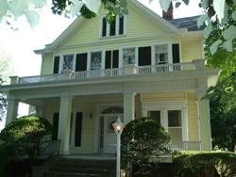
For appointment call auctioneer/Realtor Phil Thompson w/ Ohio Real Estate Auctions, Barry Baker Broker for appointment to inspect 937/606-0588. Don’t miss out on this property; owners are very motivated to sell. Starting at 9:00 A.M. Antiques & Collectibles: Walnut corner cupboard w/ glass door top blind door base; super cherry buffet w/ toenail carved feet; 2 pc. walnut bookcase desk; rnd. walnut table w/ extra leaves; oval & rectangular walnut Victorian. MT stands; Victorian settee w/ 2 side chairs; 2 vict. walnut chairs w/ needle point seats; super 7 drw. Empire cherry chest; 5 drw. walnut chest; Vict. wal. bed; spool bed; cherry & wal. turned leg night stands; drop leaf wal. stand; wal. w/ flaired grain swivel top game table; wal. dovetailed blanket chest; Boston rocker; chestnut 2 door wardrobe; hanging wall cabinet; pier mirror; ice cream parlor table & 1 chair; lg. Duncan Phyfe mahogany china cabinet; 6 matching maple caned seat chairs; 4 curved back lodge chairs; old plank bottom rocker; gate leg table; candle stand; wal. country washstand; nice 1940’s carved wood couch; wal. handmade cradle; sq. trunk; wicker magazine table, 2 chairs & rocker; cedar chest; Dickensware Weller vase; majolica plate; several oil lamps; finger lamp; bracket lamp; banquet lamp; HP china pcs. Franciscan Apple pcs; Noritake dishes; 2 early transfer creamers, 2 bone dishes; flow blue pcs. Waterford decanter set; Rubena syrup; Fenton cranberry opalescent hobnail pitcher w/ 6 tumblers; 2 covered tureens; Cosmos vase; several pcs. of HP china; HP MG cuspidor; wood sugar bucket w/ PJ Ritters Red Raspberry Jam label; Mc Coy Aunt Jemima cookie jar; several pictures & frames, 2 Currier and Ives horse pictures; Savage Art horse picture; stoneware crocks & bowls; stoneware refrigerator water container; 2 framed pictures of past Champaign Co sheriffs going back to 1849; large amount of paper goods much pertaining to Urbana. 1901 Urbana, 1911 West Liberty, 1895 N. Lewisburg city maps; 1881 repro Champaign Co History; History of WWII by Miller; Vol 1&2 History of Free Masonry; other books; letter opener w/ lighter; CI horse back side bottle opener; 2 MG hen on nest; 3 quilts; blue & white coverlet; Artifacts: 2 arrow heads one being an Archaic Notched- Base Dovetail made out of Indiana Hornstone flint other is a Stemmed Adena point made of mottled Coshocton flint; Clocks: Grandfather and Grandmother clocks both w/ walnut cabinets; real nice tall double door shelf clock; Ingram & Seth Thomas shelf clocks; Terms on personal property: cash or check w/ proper ID only. Also MC, Visa, & Discover accepted w/ 4% clerking charge. Auctioneer’s note: Selling in this auction is the former property of Jay & Elsie McKeever, Jay was Champaign County Sherriff from 1935 to 1965 and Elsie was the jail matron. This will be a very large auction with many unusual items.. Go to auctionzip.com for photos, Auctioneer ID # 5640
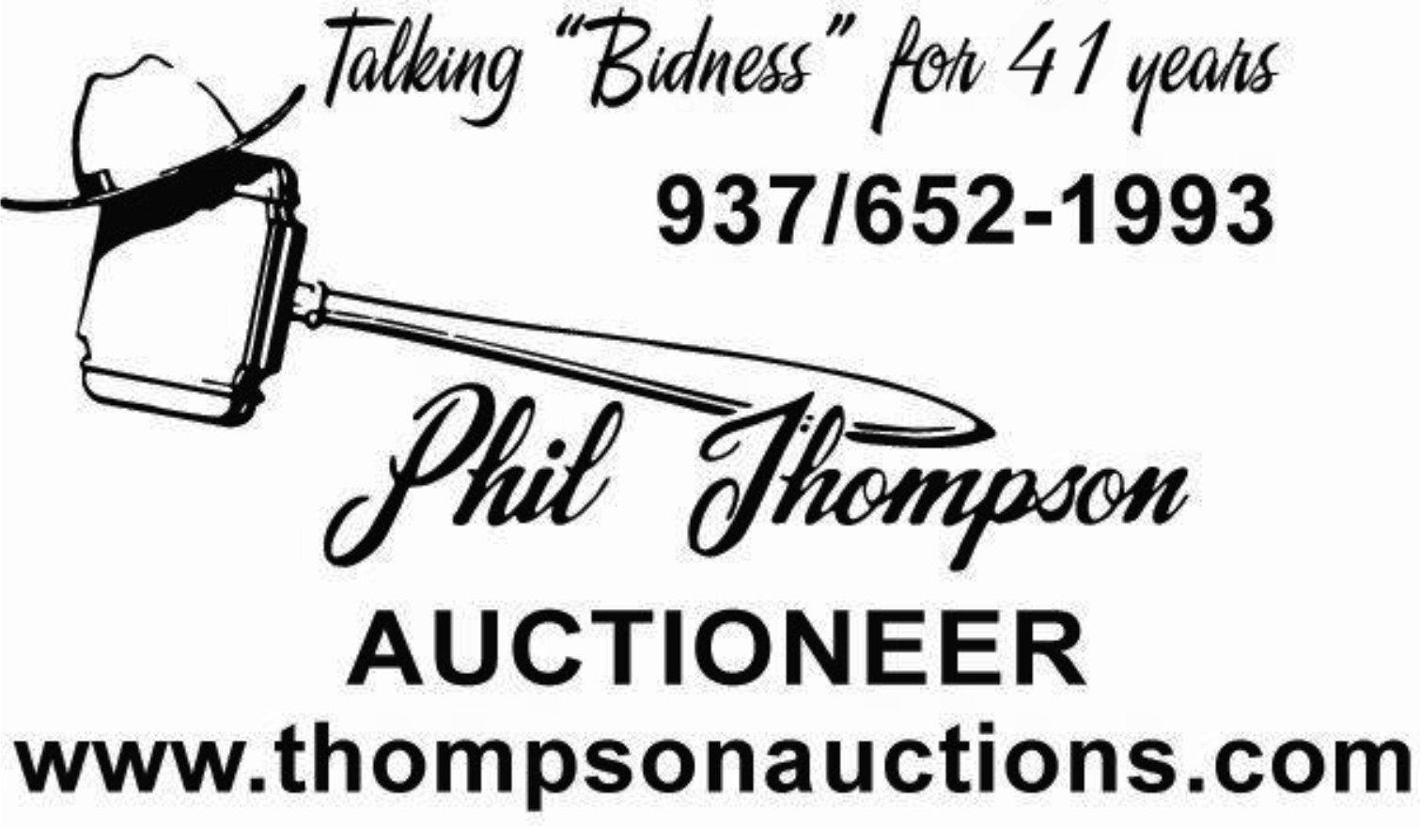 | Karen McKeever,  William McKeever &  Julie Monnin Owners  Food by  “THE FARMER’S DAUGHTER

