**20.09 Acres +/- Farmland Auction**

**Pleasant Township, Henry County, Ohio**

**Tuesday, August 27, 2024 – 6:30PM**

**Auction Location:** VFW Post 8847, 922 Walnut Street, New Bavaria, OH 43548.

**Productive Farmland at Live Public Auction:** This property is located in Section 28, Pleasant Township, Henry County, OH, which is at the intersection of County Roads 17 and 16C. The property will be offered in one tract at a live-only auction. This is a drained rectangular 20.09 +/- acre parcel with no buildings and fronts on County Road 17. It is mostly Hoytville Clay soil.

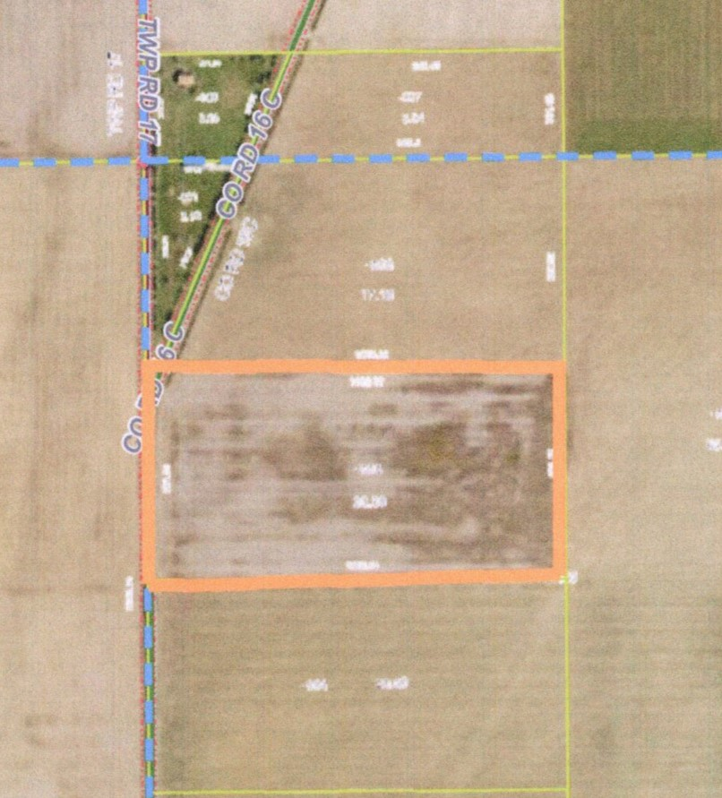

**Terms:** NO BUYER’S PREMIUM. Live-only auction. No online bidding. $10,000 down day of auction, with balance due at closing on or before 45 days. Guaranteed Certificate of Title and Warranty Deed with prorated real estate taxes. Possession at closing or after current crop is harvested, whichever is later. Statements made sale day take precedence over all printed material. Information is believed correct, but not guaranteed.

**Steve’s Note:** Good, productive land to add to your farming operation, buy as an investment, a first farm purchase, or the start of a country residence or hobby farm. Call, text or email auctioneer for a detailed Bidder’s Packet with more information. See you there!

**OWNER: Jim Rickenberg**

**Attorney: James D. Rode, Sunderman & Rode LLC.**

**AUCTIONEERS: Steve Powell and Shad Ridenour, Bowling Green, OH.**

**Phone/Text: (419) 304-1263, Email – smpowell53@gmail.com**

**BROKER: Ohio Real Estate Auctions, LLC.**



**www.ohiorealestateauctions.com**

Auctioneers are licensed and bonded in favor of the State of Ohio. Not responsible for accidents or loss.