July 15, 2024

To: Prospective Farmland Auction Bidder/Buyer

From: Steve Powell and Shad Ridenour, Auctioneers

Re: Rickenberg Farm Auction Information

We would like to inform you about and invite you to our upcoming farmland auction. Here is a brief description about 20.09 acres m/l (according to Henry County Auditor records) of productive farmland in Section 28, Pleasant Township, Henry County, Ohio that we will be offering at a Live-Only Public Real Estate Auction.

**Auction Date and Time:** Tuesday, August 27, 2024 at 6:30PM.

**Property Location:** At the intersection of Henry County Roads 17 and 16C and fronts on Road 17. Watch for our sign.

**Auction Location:** VFW Post 8847, 922 Walnut Street, New Bavaria, OH 43548.

**Auction Details:** This Rickenberg property will be offered as one parcel at a live-only public auction.

**Property Details:** This real estate is located in the Holgate Local School District.

Henry County Auditor parcel number 12-280004.0000. Current property taxes under Current Agricultural Use Valuation (CAUV) are $859.44/year. This land is mostly Hoytville Clay soil.

**Auction Terms:** Live auction only, no online bidding. If you cannot attend in person, ask us about making arrangements to bid. There will be no Buyer’s Premium added to your final bid. Possession of the property will be granted at closing or after the current crop is harvested. Successful bidder/buyer(s) will complete a Contract to Purchase Real Estate and provide a $10,000 earnest money deposit on the day of the auction. This property is being offered in “as is condition, all faults included”. Come prepared to bid and buy at your price, as there will be no contingencies for financing, inspections, appraisals, or any other reasons. Other more complete auction details and terms will be provided in the Bidder’s Packet and at the auction.

Please feel free to call, text or e-mail if you have any questions. Thank you in advance for your potential interest in this property.

Sincerely,

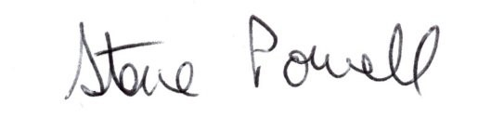 Shad Ridenour

Steve Powell, Auctioneer/Agent Shad Ridenour, CAI, Auctioneer/Agent

Request a Bidder’s Packet containing detailed terms of the auction, Farm Service Agency information, soil types and additional information by completing this form and mailing to Steve Powell, 17110 Kellogg Road, Bowling Green, OH 43402, or sending an email request to smpowell53@gmail.com, or calling/texting to 419-304-1263.

Name________________________________________________________________

Mailing Address_______________________________________________________

City_________________________ State_______________________ Zip _________