Public Real Estate Auction
Tuesday, May 17, 2022 – 5:30PM
Auction Location: A live auction to be held at the property at 865 Mulberry Street, Perrysburg, OH 43551. Which is 400 feet southeast of the intersection of Findlay and Mulberry Streets.
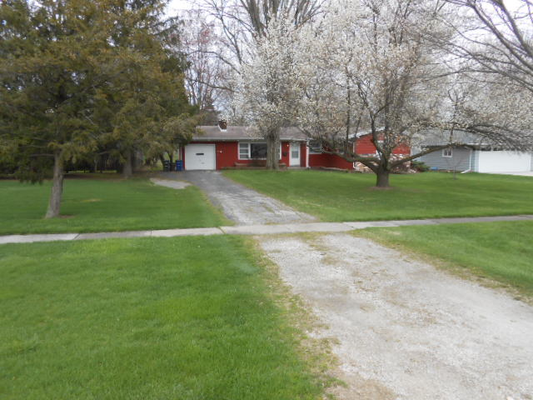

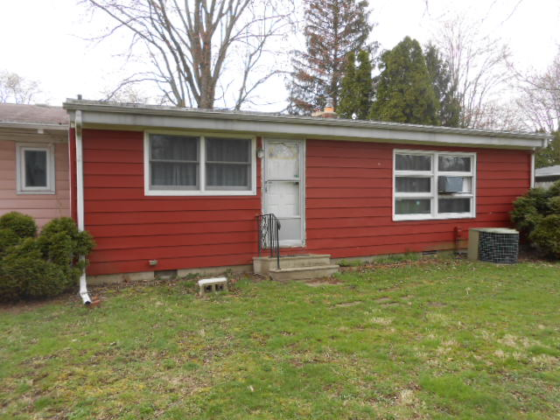
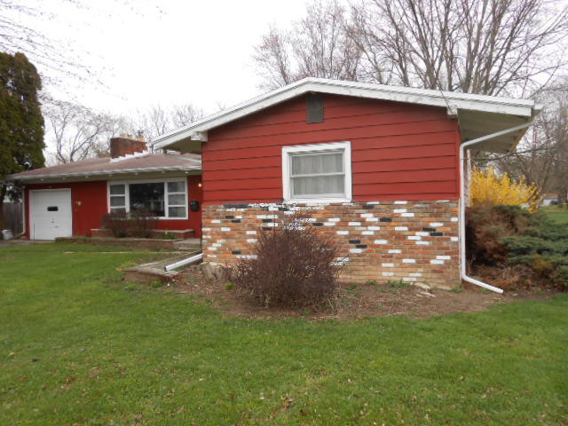

Four bedroom, 2 full bath ranch house features: Mature treed half-acre 80’ x 272’ lot, large front yard, very deep back yard, quiet street, eat-in kitchen, living room with wood-burning fire place, family room, master suite, natural gas forced-air heat, central air, attached one car garage, asphalt driveway, city water and sewer. All this house needs is your finishing touches to make it your home or a productive rental house. Property taxes have been $ 1,689.23/half-year.

Come take a look. Open House – Saturday, May 7, 1 – 3PM.

TERMS: NO BUYER’S PREMIUM. The property is being offered in “as is condition”. Buyer will provide a $2,000 non-refundable earnest money deposit on the day of auction. Balance is due at closing on or before 45 days. Buyer(s) will receive Guaranteed Certificate of Title and Warranty Deed with proper real estate tax proration by the Lucas County method. Possession will be at closing. Have your financing arranged and come prepared to bid and buy. Statements made sale day take precedence over printed material. Information is believed correct, but not guaranteed.

Steve’s Note: Contact auctioneer for a detailed buyer’s packet with more information. See you there!

OWNER: Renate Graubart Estate
Darla Schulte, Administrator
Wood County Probabte Case Number 20201199.

AUCTIONEERS: Steve Powell and Shad Ridenour, CAI
Bowling Green, OH
Phone: (419) 304-1263, Email – smpowell53@gmail.com


BROKER: Ohio Real Estate Auctions, LLC.

Auctioneers are licensed and bonded in favor of the State of Ohio. Not responsible for accidents or loss.

