ABSOLUTE AUCTION
Saturday September 7 @ 10:00AM Real Estate sells at 12 Noon
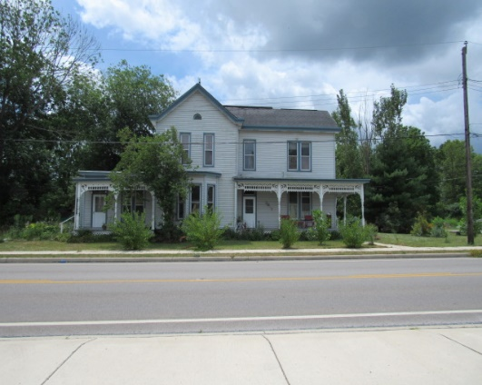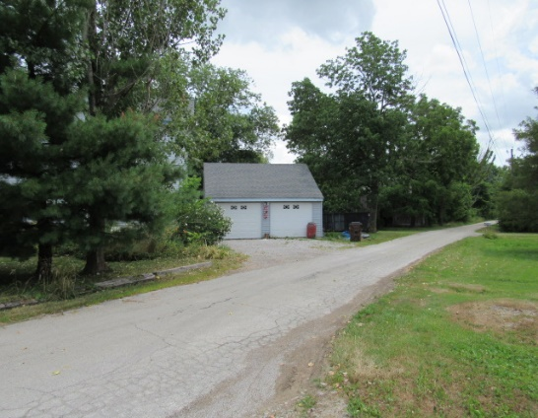
3811 U S Route 50 Fayetteville (Marathon), OH 45118
Interior Inspections: Sunday August 25 (1:00-3:00PM), Wednesday Eve. Sept. 4 (6:00-8:00PM), day of auction beginning at 10:00AM, or by appointment with Dave P. Lewis 513.724-3903
REAL ESTATE SELLS AT 12 NOON - Situated on a 0.714 acre corner lot in the Village of Marathon, Jackson Township, Clermont County is this 2 story frame home which was previously used as a 3 family residence. The home is in need of some TLC but features 5 bedrooms, 3 full bathrooms, 2 car detached garage, pump house, and barn. According to the Clermont County Auditor the home was constructed in 1870 and the newer detached garage was built in 1989. The first floor features 6 rooms containing 2 kitchens plus there are 2 full bathrooms. The second level has 4 rooms which includes a kitchen plus there is a full bathroom. A nice wrap around style porch completes the home. The property is serviced by county water and a septic/aeration system.
The home and lot was appraised for tax purposes in 2017 at $117,900. Clermont County PID # 142313.023P.
Personal Property begins selling at 10:00AM – There is no telling what is in the home. Mrs. Squire was a hoarder. Visit AuctionZip under Auctioneer #7414 to view a list of many of the items of interest

Additional pictures, information, and terms of sale can be found at OhioRealEstateAuctions.com
Real Estate Personal Property
David P. Lewis Agent/Auctioneer Lewis Auctioneering LLC Ohio Real Estate Auctions LLC David P. Lewis & David S. Lewis 513.724.3903 513.724.3903

