REAL ESTATE PUBLIC AUCTION
Located: 395 Mill Street, (State Route 245)North Lewisburg Ohio 43060
SATURDAY DECEMBER 19TH 1:30 PM
Please Note: New survey real estate consisting now of 2 story, 4 bedroom 1 1/2 story older home, kitchen with cabinets, 1 bath, attached 1 car garage. older geo-thermal furnace and wood burner stove. newer vinyl clad replacement windows, newer water heater, water softener. | 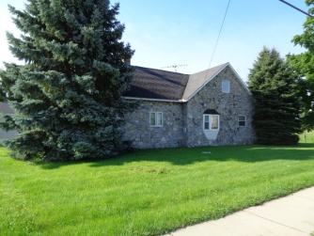
Large wooden deck on rear of home. (2) Quonset buildings one 36'x54' w/ 16 high doors, other is 30'x32' w/ 14' high doors. Excellent for equipment storage, boat, RV or shop area, both have concrete floors and electric. This property also has enough frontage and depth that a approvable building lot on east side of house is possible. All on 1.001 acres. Terms: $10,000 non refundable deposit down at auction, balance at closing within 30 days. Property selling in its present AS-IS condition, no buyer's contingencies, as to financing or inspections. Any inspections need to be made prior to bidding. Real estate taxes are estimated to be $705.00 per half and will be prorated to day of closing. Selling to the highest bidder with confirmation of owner. Shown by appointment call Auctioneer Phil Thompson Realtor w/ Ohio Real Estate Auctions Barry Baker Broker 937/606-0588. Home has a great location. Auctioneer's note: No personal property, only real estate, don't miss it.
Village of North Lewisburg
Owner

