REAL ESTATE PUBLIC AUCTION
Located at 395 Mill Street, North Lewisburg Ohio 43060
THURSDAY OCTOBER 8TH 5:30 PM
Real estate consisting of 2 story, 4 bedroom 1 1/2 story older home, kitchen with cabinets, 1 bath, attached 1 car garage. gas forced air furnace & boiler located in basement, also wood burning heat stove. newer vinyl clad windows, newer water heater, water softener. 24' x 30' Quonset building. All on .665 acres. | 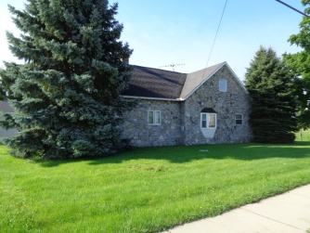
Large wooden deck on real of home. This property has enough frontage and depth that a approvable building lot on east side of house is possible. Terms: $10,000 non refundable deposit down at auction, balance at closing within 30 days. Property selling in its present AS-IS condition, no buyer's contingencies, as to financing or inspections. Any inspections need to be made prior to bidding. Real estate taxes are estimated to be $705.00 per half and will be prorated to day of closing. Selling to the highest bidder with confirmation of owner. Open House: Wed Sept 23rd 5 - 6PM or by appointment call Auctioneer Phil Thompson Realtor w/ Ohio Real Estate Auctions Barry Baker Broker 937/606-0588. Home has a great location. Auctioneer's note: No personal property, only real estate, don't miss it.
Village of North Lewisburg
Owner

